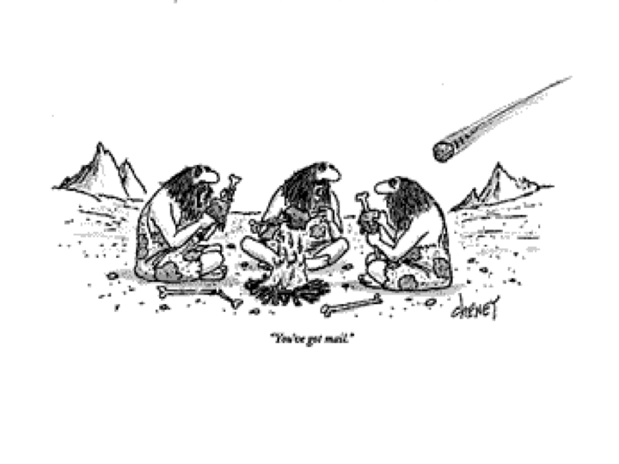
You’ve to mail
The DNA of Government - Editorial Board Meeting #1

Date: Tuesday, November 20, 2012
Time:12 00 - 13 00 EST
Location: 720 Bathurst Street, 2nd Floor Meeting Room, Toronto
Teleconference: Toll Free Number: 1-866-602-7211
Telephone Number: 416-933-3840
Global Toll Free Number: 800-0170-8098
Conference ID: 1923884
Moderator PIN: 5071

AGENDA

1- Welcome & IntroductionsJJ 5 min

2- Editorial Board - Modus OperandiSkip40 min

3- Book Publishing ProcessJJ10 min

4- Other Business

5- Next meeting: Tuesday March 12, 2013 (Skip & Co-Authors)

